Fortify Project

SRS Documentation

DEVELOPMENT TEAM

Paulina Katarzyna Wesolowska

Shravan Paladugu

Ali Adil Abdulrazzq Al-Kinani

Abigail Chong

Beatrice Jeruto Rerimoi

David Wang

Harry Singh

Hassan Madni

Nadia Maharani Azhari

Tom Edmondson

WRITTEN BY

Abigail Chong

Nadia Maharani Azhari

Table of Contents

1. Company Introduction 2

2. Project Description 3

2.1 Purpose 3

2.2 Intended Audience and Use 3

2.3 Scope 3

3. Overall Description 5

3.1 User Needs 5

4. Website Features and Requirements 6

4.1 External Interfaces 6

4.1.1 Clear Information 6

4.1.1.1 Homepage 6

4.1.1.2 Organisation Profile Page 8

4.1.1.3 Volunteer Profile Page 9

4.1.1.4 About Us Page 9

4.1.2 UI/UX Design 10

4.1.3 Self-Assessment Survey 10

4.2 System Features 8

4.2.1 Login and Sign Up 8

4.2.2 Separate Profiles for Volunteers and Organisations 9

4.2.2.1 Volunteers 9

4.2.2.2 Organisations 9

4.2.3 Matchmaking tool 9

## Company Introduction

Hardhat Enterprise is an enterprise formed by students with the aim to design tools to be used in assisting white hat operations. They provide students with the opportunity to build up their skills, broaden their knowledge, network and produce useful deliverables.

Currently, Hardhat is conducting five interrelated projects that all contribute to the goals of the company. Every deliverable developed through each project will be open-sourced and used by anyone. The Hardhat Enterprise aims to create outcomes that are beneficial to the public through the improvement of existing tools or filling a market need that is not met yet.

The five projects are:

* Fortify

Creates a platform to connect cyber security volunteers with small organisations in strengthening their security systems

* Nasa Protocol Exploit

Attempts to find vulnerabilities and create exploits with protocols used by NASA

* Breaking CAPTCHA

Develops machine learning AI and computer vision model to solve CAPTCHA problems

* AppAttack

Penetration testing on apps made by Deakin University

* Penetration Testing GUI

Research, design, develop, and implement software that aids the process of enumeration and exploitation of remote systems

Figure 1 The relationship between the five projects

### 

## Project Description

### Purpose

The Fortify project aims to create a platform that connects cyber security volunteers – students, graduates, and self-taught professionals – with small organisations that do not have the resources to hire a cyber security team in strengthening their security systems. This platform will provide volunteers with the opportunity to work on real-life projects and apply their skills and knowledge while gaining the soft skills needed in working environments. The website will also open up opportunities for future cybersecurity professionals and clients to connect and expand their networking landscape. Fortify also fulfils the goals of Hardhat Enterprise filling the gaps in the market, through the raising of employability for students who struggles to find jobs due to their lack of experience. The projects conducted will be useful in their portfolio enhancement, thus increasing their employability rate. Through this project, Hardhat Enterprise can also emphasise the importance of cyber security in all businesses and organisations, no matter big or small.

### Intended Audience and Use

As this project will be undergone over several trimesters, this document serves as a guide to future employees working on the Fortify project. This documentation will be saved in the Fortify cloud folder, where all related members of the project will be able to access it and gain insight into the website’s purpose, plans, designs, features, and requirements. The document will also be available to the director of Hardhat Enterprise. Future employees can seek out this document to identify a starting point from where we left off this trimester. Once completed this document may also be accessible to the AppAttack team for the analysis of possible vulnerabilities.

### Scope

The outcome of this project is to create a website where volunteer cybersecurity professionals and students can connect with small businesses or organisations in assisting them in their security assessment and management. Through this platform, small organisations will be matched up with a compatible volunteer who will assist them with the security concerns of their businesses. Through this interaction, small organisations will gain an insight into the importance of cyber security management and provide them with a head start on the security plans for their businesses.

The UI/UX of the website will be simple – with easy-to-read fonts and light colours – to make it easier on the eyes of all users that explore the website. The website will also include all necessary information regarding the website with its aims, purposes, and roles. In addition, organisations may also get to know their volunteers through the information listed on the volunteer’s profile page, providing them with the assurance of knowing who they are working with.

When volunteers and organisations sign up, they will be required to complete a survey to rank their knowledge and security level. The information later would be used by the matchmaking tool in assisting to find the compatibility between a volunteer and an organisation to find the best possible match to achieve the targeted goals. The information provided by each organisation is given to the volunteers in assisting them in their assessment.

## Overall Description

### User Needs

The Fortify website will provide opportunities for students who struggle to find jobs without experience, as it provides volunteer students, graduates and self-learned cyber security professionals the opportunity to apply their knowledge and skills through the participation of real-life projects with clients. This website will also act as a networking platform, where they will be able to connect with others who are in a similar position as them.

Another aim of this website is to assist small businesses or organisations who are unable to employ specialists due to the high costs. Organisations can seek out assistance through this website which will provide them with all sorts of cyber security needs necessary for an organisation.

### 

## Website Features and Requirements

### External Interfaces

#### Clear Information

The Fortify website consists of five web pages – Homepage, Organisation Profile Page, Volunteer Profile Page and an About Us Page.

##### Homepage

The Homepage incorporates the main objectives and purpose of the project so that customers may be able to see firsthand when accessing our webpage.

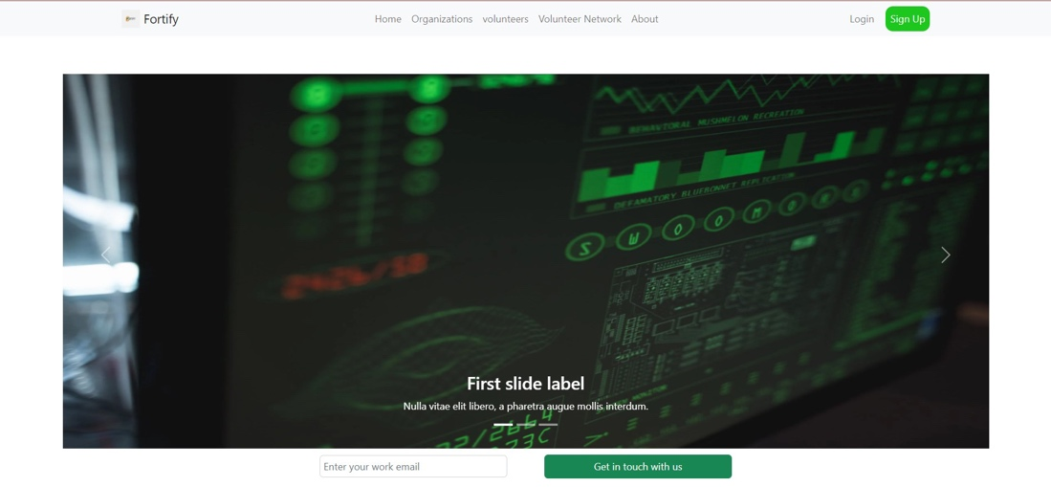

Figure 4.1.1.1.1 Homepage

Within the homage, we have inserted a short YouTube video that explains what Cyber Security is to give the browsers some insight into what Fortify does, why it is important and how it supports Fortify’s goals.

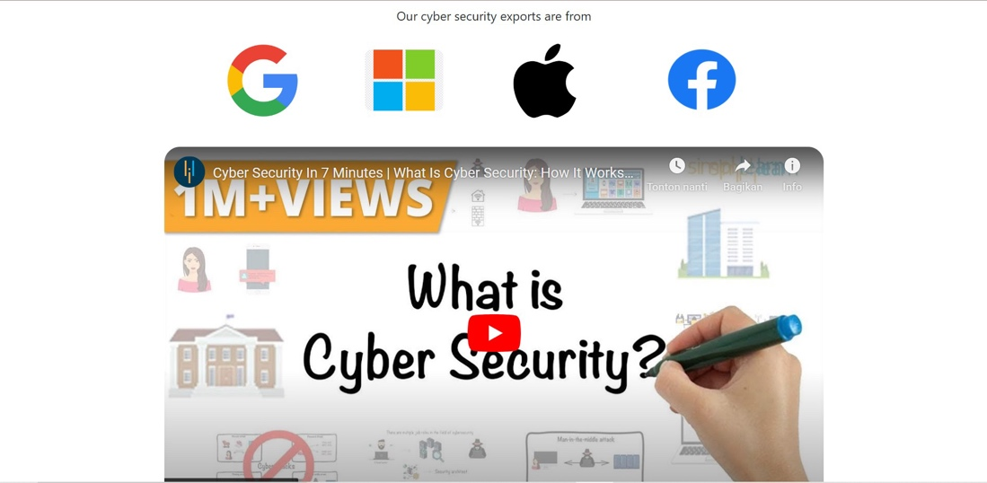

Figure 4.1.1.1.2 Short Video on Cyber Security

We also included the latest statistics on Cyber Security attacks or incidents, as well as damage costs to show potential clients of the possible consequences that may occur due to the lack of cybersecurity measures. Graphical user interface, application

Figure 4.1.1.1.3 Cyber Security Statistics

Furthermore, we listed the services Fortify can provide to customers and how they may be of use to future clients.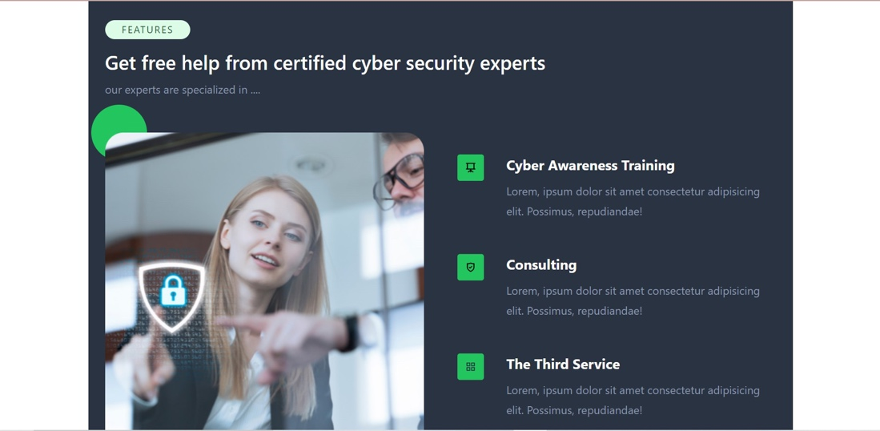

Figure 4.1.1.1.4 Fortify Services

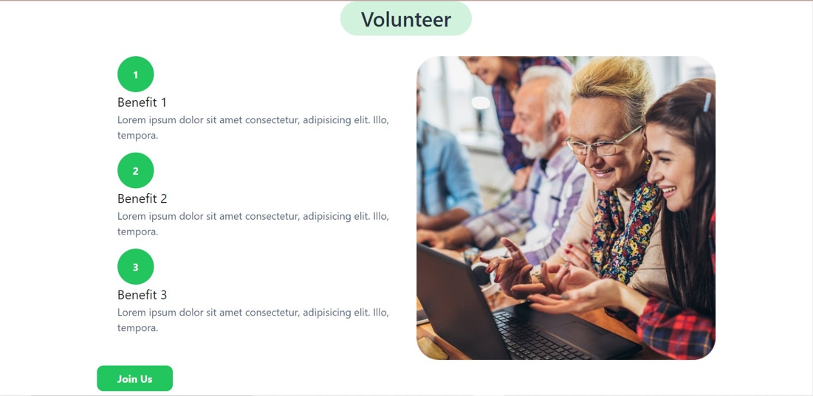

Figure 4.1.1.1.5 Volunteer roles

Embodied at the bottom of the homepage are Fortify’s contact details – which include an email, contact number and links to social media accounts – and a contact us form.

Figure 4.1.1.1.6 Contact Details

Figure 4.1.1.1.7 Contact Us Form

##### Organisation Profile Page

The Organisation Profile Page lists all the clients that Fortify volunteer and have worked for. Each listed organisation includes a brief summary regarding their business and ratings on the cyber controls they have applied to their organisation. Below each rating is a more info button which can lead to a separate webpage that holds more details regarding the business and the assessment summary conducted by the volunteers.

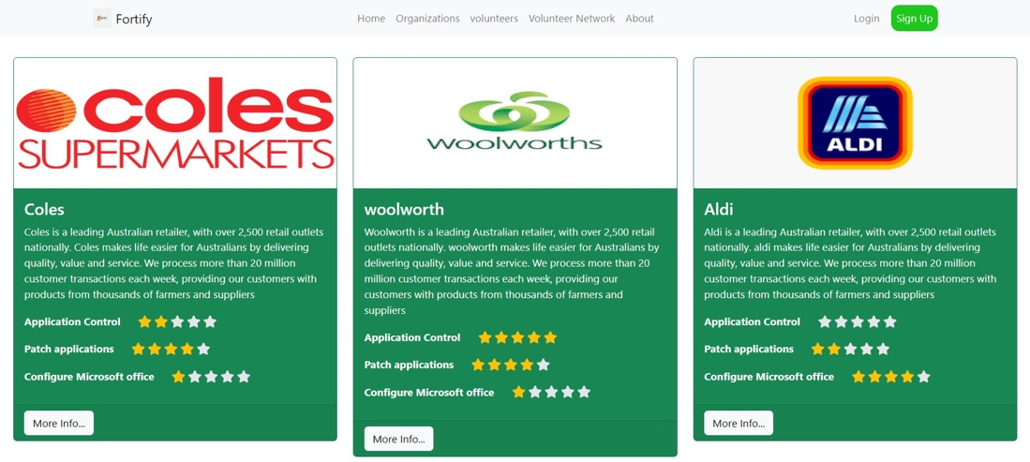

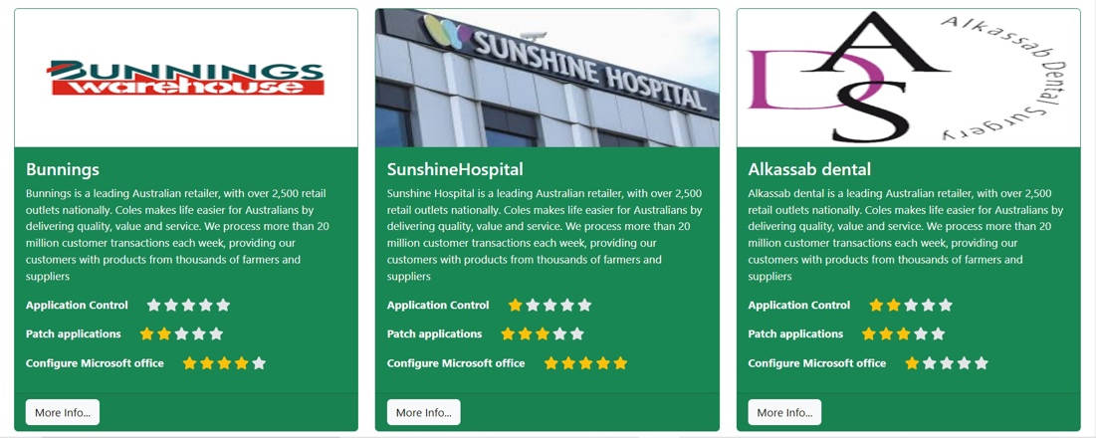

Figure 4.1.1.2 Organisation Profile Page

##### Volunteer Profile Page

Similar to the Organisation Profile Page, the Volunteer Profile Page lists all the volunteers who work with Fortify. Each volunteer includes a brief summary about them and their skills in the area of cyber security. Similarly, underneath the rating, there is also a more details page which will lead to more details about the volunteer.

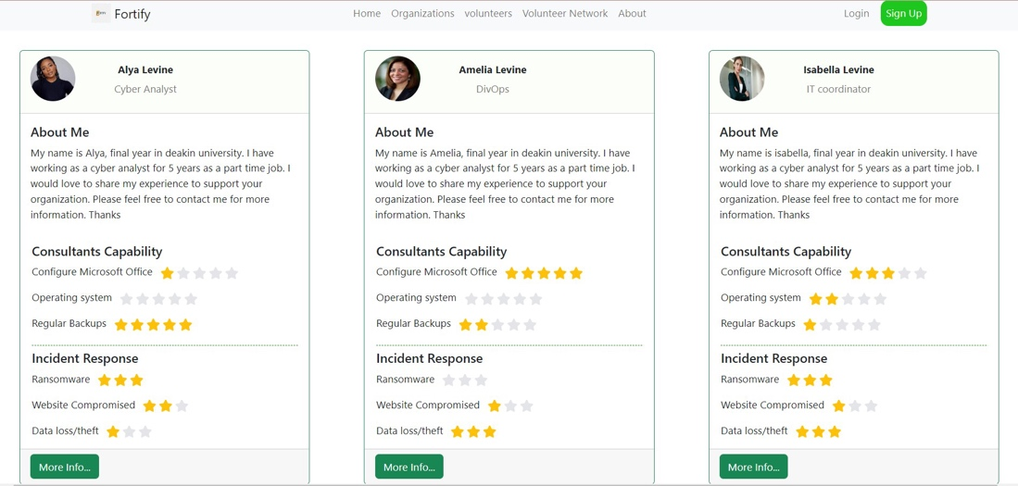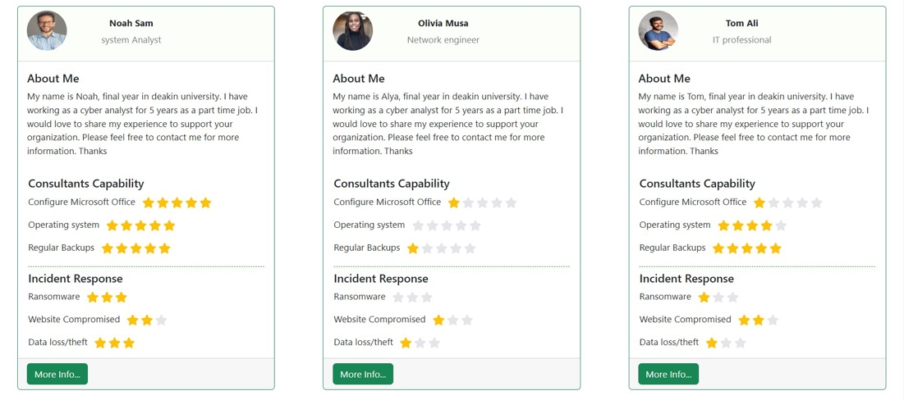

Figure 4.1.1.2 Volunteer Profile Page

##### About Us Page

The About Us Page elaborates further from the Homepage. It incorporates information regarding Fortify including its aims and goals.

Figure 4.1.1.4 About Us Page

#### UI/UX Design

The website is designed with a simple layout which makes it more user-friendly and is constructed from HTML, CSS and JavaScript. Fonts used are easy to read – sans-serif – as it will be more straightforward to catch for users. We avoid using complicated and rustic fonts to keep the website clean and more utilized. This way, it will help users understand the information and contents provided more easily. For the colour used, we stick to the colours that are used on the website prototype—which are green and dark blue. By using two colours only for the design, it keeps the website looking neater and cleaner. For the font colours, we decided to go for neutral colours to avoid the website looking complicated. These colour choices enhance the website appearance to look more colour-coordinated and ensure readability for users while also keeping it simple, modern, and eye-catching. We made our structure straightforward, with a navigation bar at the top of each page to provide easier navigation for users to search for content or pages they would like to explore further.

#### Self-Assessment Survey

In the process of sign-up, organisations and volunteers are required to complete a self-assessment survey to determine the level of security implemented by their organisation and the skills each individual holds.

The questions ask targets regarding their knowledge, capability and skills in:

* Application Control
* Patch Application
* Configure Microsoft Macro Settings
* User Web Application Hardening
* Restrictions and Privileges
* Patch Operating Systems
* MFA
* Backups
* Penetration Testing
* Cyber Security Policies, Strategies and Awareness
* Producing Compliance Reports
* Ransomware Attacks
* Compromised Websites, Accounts and Systems
* Data Loss and Theft
* Malware and Viruses

The self-assessment survey targeted at the organisations requires respondents to assess their organisation’s cyber security level by ranking each technical control from a maturity level of 0 to 3. In addition, the organisation also have to rank their skills and their capability in responding to cyber situations. From the rankings, a volunteer from Fortify will assess each category and set a Fortify-confirmed maturity level. The overall results will be the basis of the cyber security assessment to build on a precise security plan targeting the organisation.

During the sign-up, volunteers also have to complete a survey ranking their skills from a maturity level of 0 to 3. Similar to the self-assessment survey on the organisation, a senior Fortify volunteer would have to assess their skills on a general level before they are officially accepted as an employee.

We have tried to simplify the questions so that beginners who lack technical understanding can comprehend each statement, but there may be some unavoidable technical terms that they may not understand. If so, respondents may ask for assistance from a volunteer.

### System Features

#### Login and Sign Up

We have designed a unified sign-up page for volunteers and organisations. The sign-up page is simple. The users only need to input their name, email address, and password and select a checkbox identifying if they are a volunteer or an organisation. There is also a comment box that users have the option to use to relay additional information to the admin. After the basic sign-up, individuals would be required to complete a self-assessment section.

Figure 4.2.1.1 Sign Up

For the Sign In page, users can simply just input their email address and password. Additional security features such as multi-factor authentication may be implemented in the future.

Figure 4.2.1.2 Sign In

#### Separate Profiles for Volunteers and Organisations

##### Volunteers

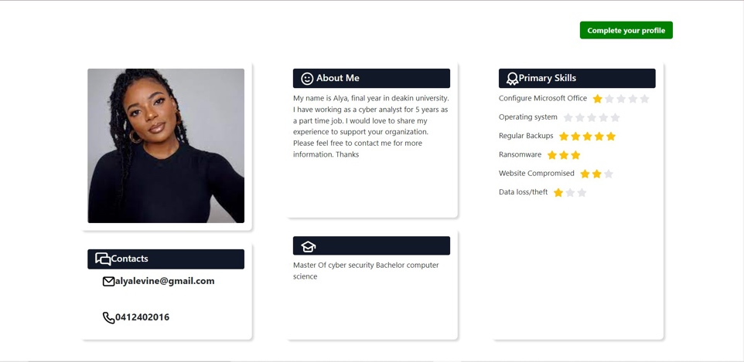The volunteer's page will be available to view for Fortify’s clients. This page displays more details about the volunteers. There are five sections on this page. The first one is the volunteer’s profile picture. Below that, we can see the Contacts section, which gives us information about the volunteer’s contacts. Next to the profile picture is the About Me section, which is where the volunteers can write a brief description of themselves. Below is the Qualification section, which provides the volunteer’s educational background. And the last section on this page is Primary Skills, which consists of the skills that each volunteer has and how advanced they are in each of the skills.

Figure 4.2.2.1 Volunteer’s Profile Page

##### Organisations

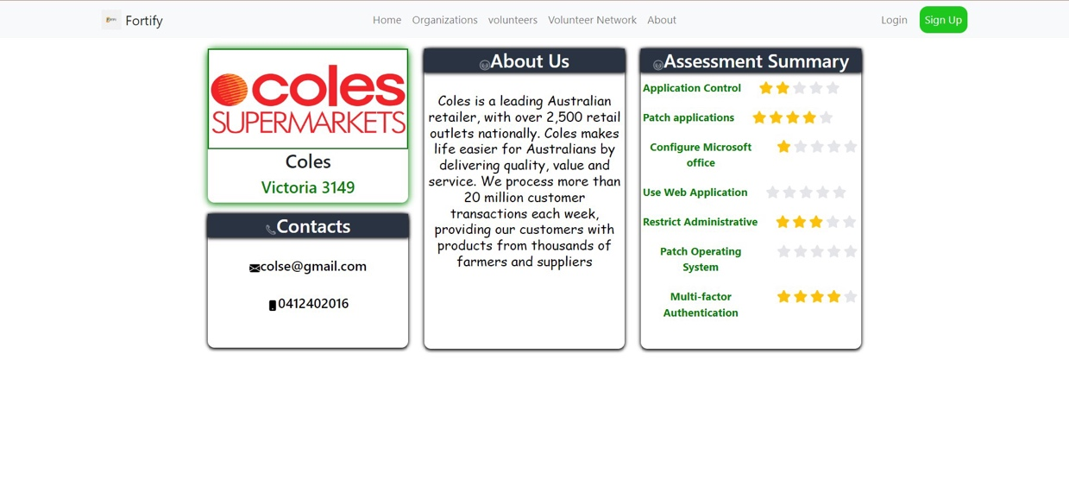We also have the Profile section for Organisations. This page contains four sections. The first section is the logo of the organization and its location. Below it is the contact details. Next to those is the About Us section, which can be used by the organization to provide a brief description of themselves. And then next to it, there is an Assessment Summary section, which will display the results of the assessment that the organization has taken when they are signing up for Fortify.

Figure 4.2.2.2 Organisation’s Profile Page

#### Matchmaking tool

The overall aim of Fortify is to assist small businesses with their cyber security measures. With this aim, we incorporated a matchmaking tool that would match an organisation to a volunteer base on the compatibility of the volunteer’s skills with the organisation’s requests. The tool will make use of the information provided by the organisations and volunteers to determine the most probable match. Through this matchmaking service, the organisations will be able to work with a volunteer who has the required skills for the services requested.